1. Data Ingestion: Cloud Storage
   1. Write GCP Helper Python Script to perform Upload

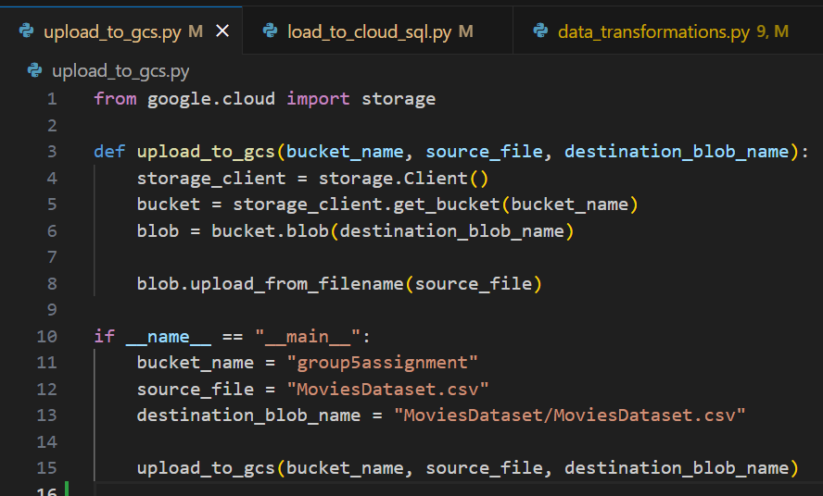

* 1. Upload the MoviesDataset CSV file to a Cloud Storage bucket. 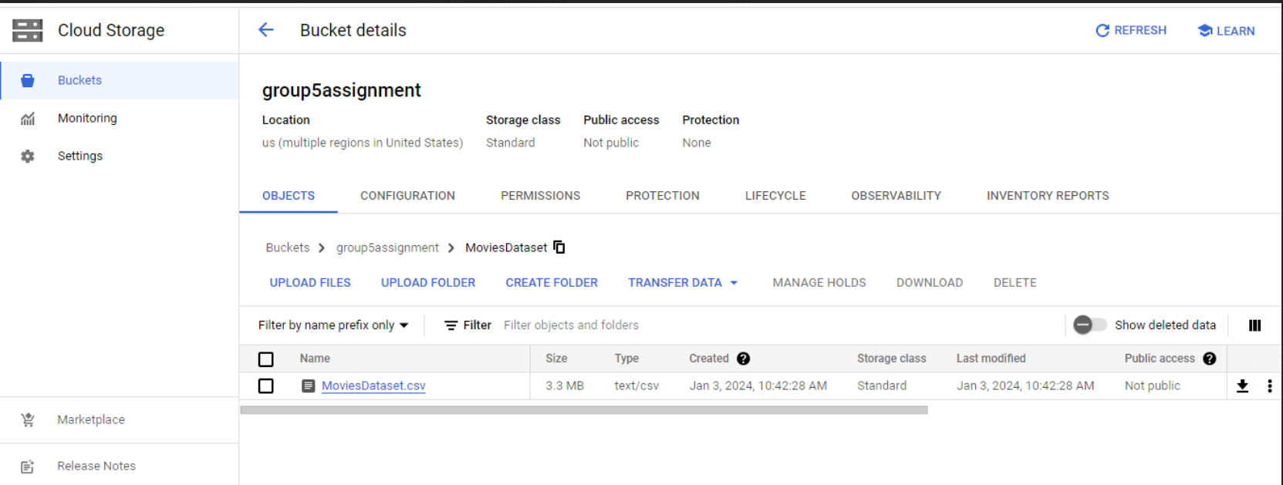

1. Data Storage: Cloud SQL
   1. Create a Cloud SQL instance (PostgreSQL/MySQL) to store normalized movie data using GCloud Utility.
   2. Design and implement a database schema that accommodates the dataset structure using SQL Client(CLI/GUI).
   3. Using PySpark Load the data from Cloud Storage into the Cloud SQL database.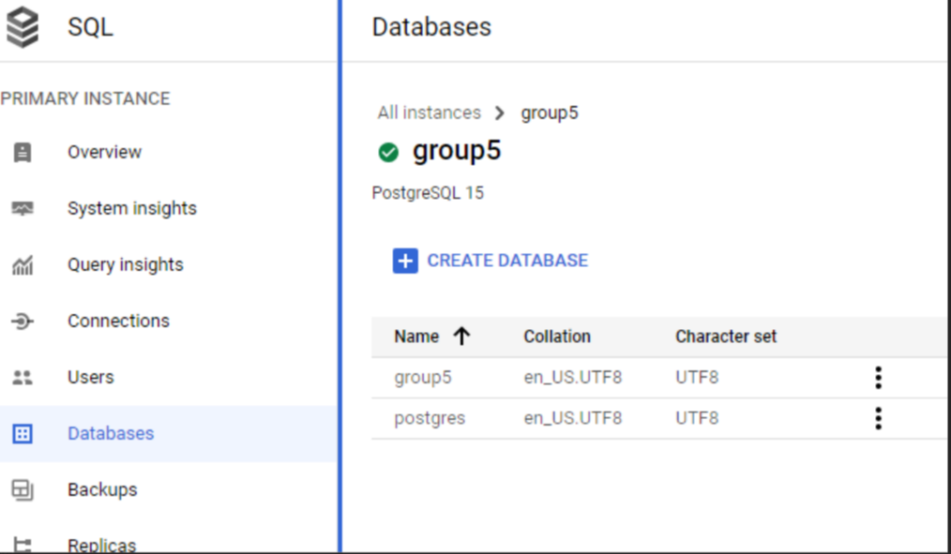

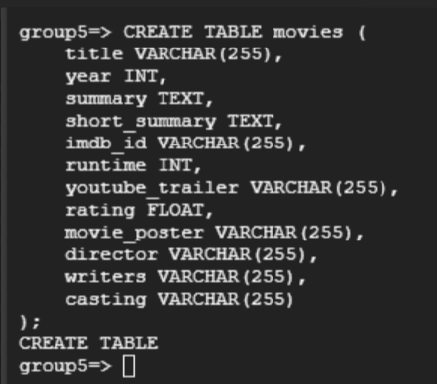

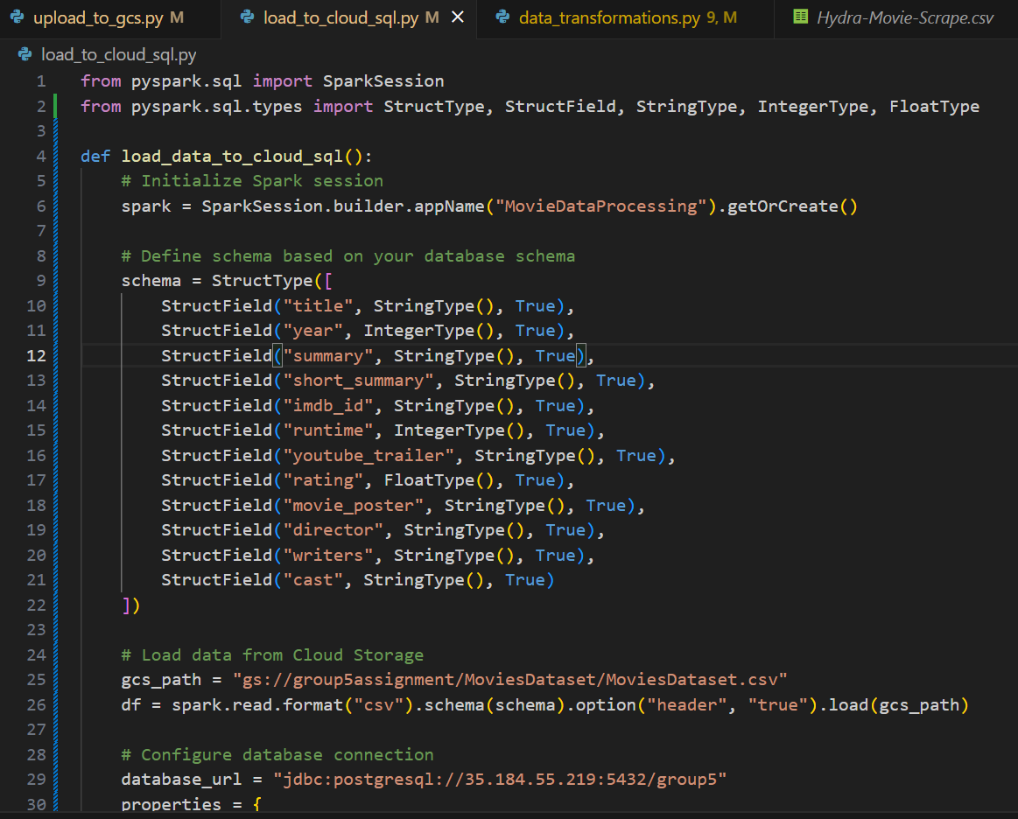

1. Data Processing: DataProc/DataFlow

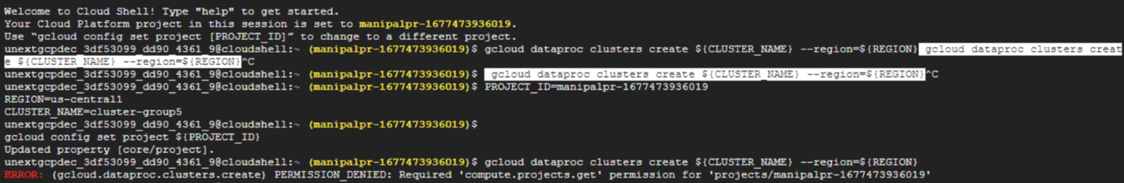

1. Big Data Storage: BigTable

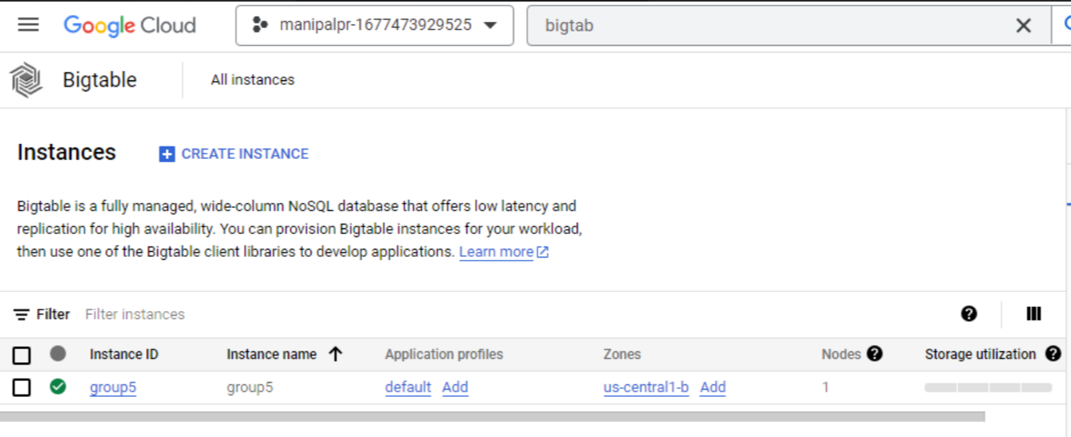



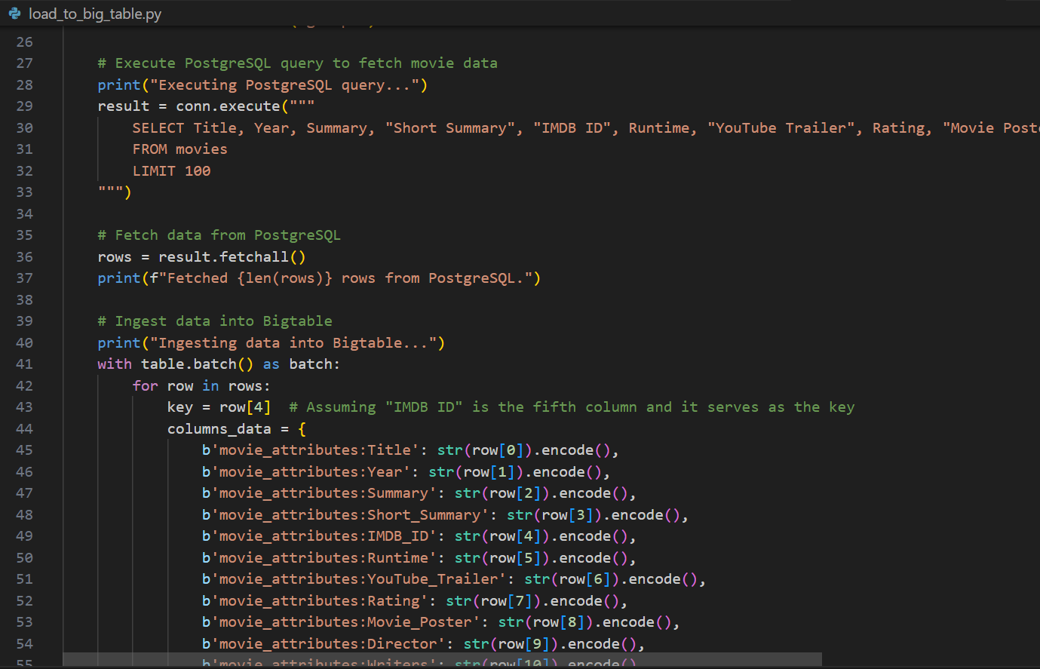

1. Event-Driven Architecture: Pub/Sub

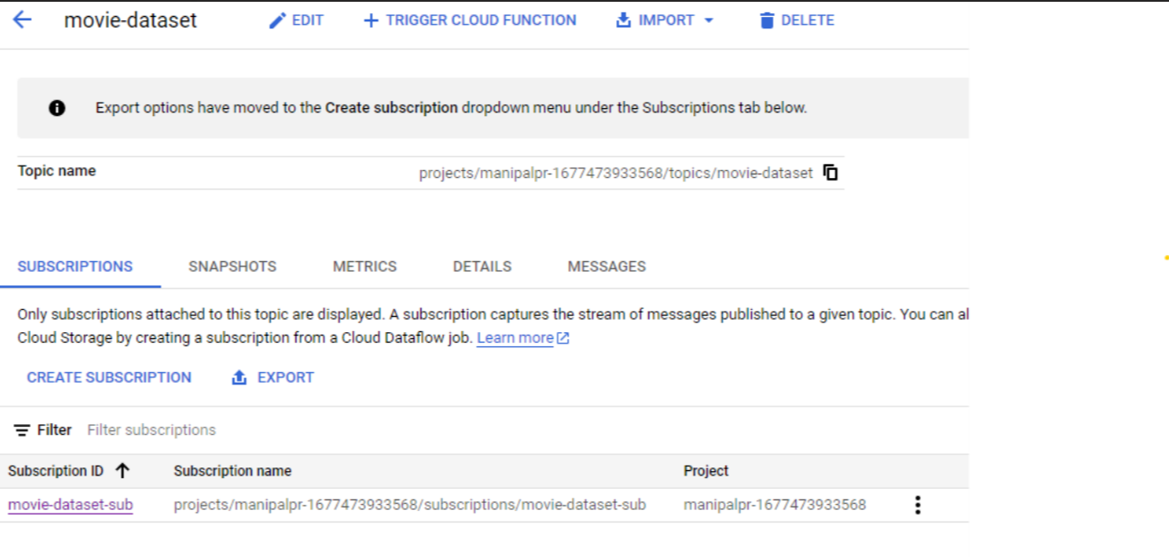

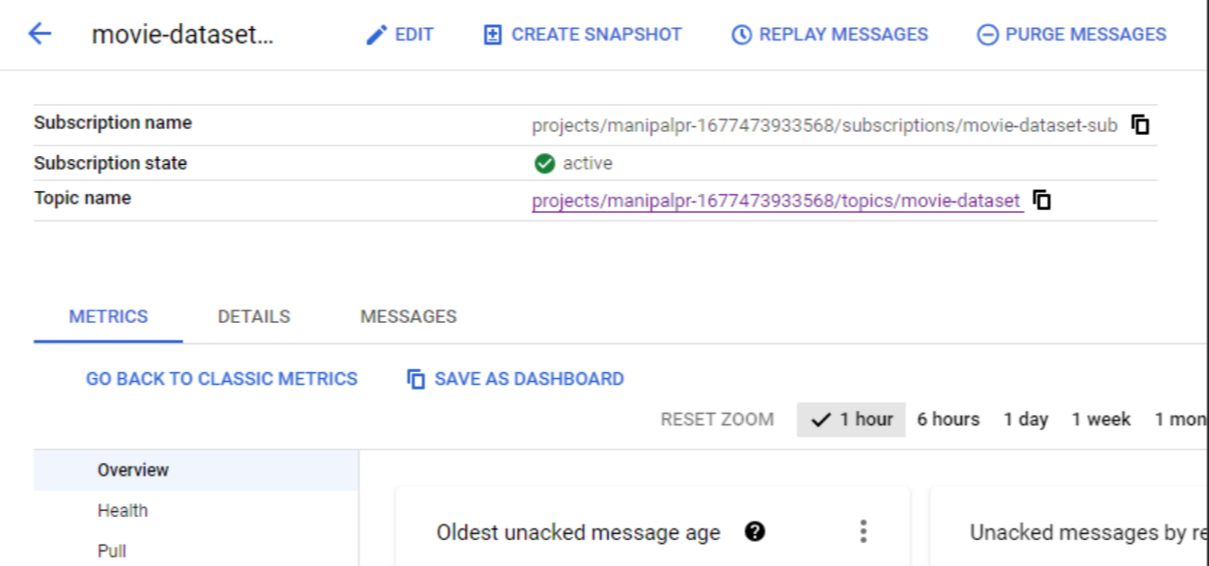

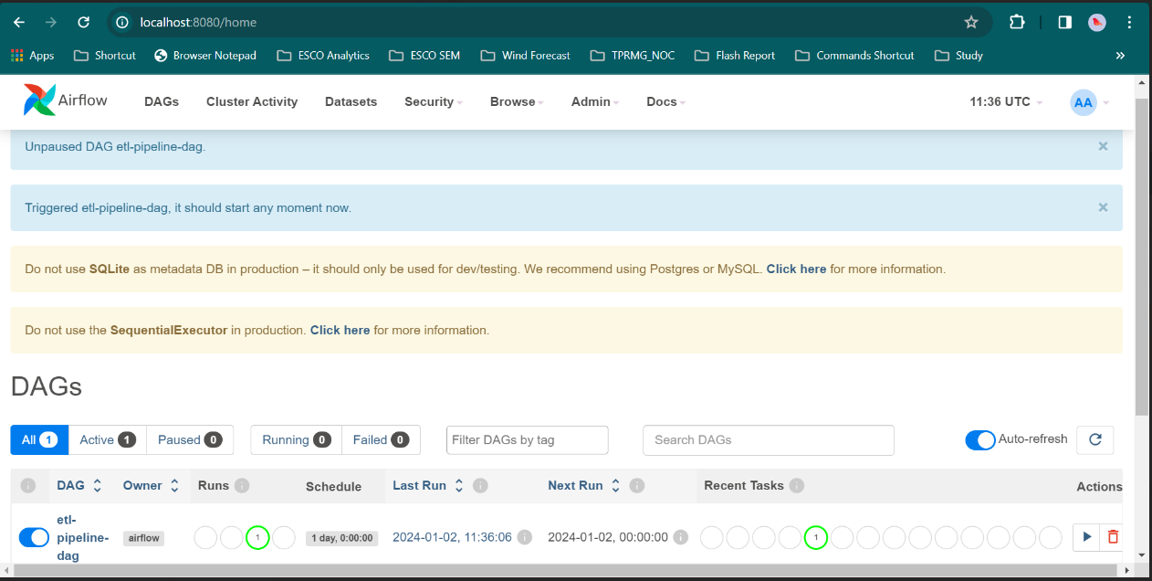

1. Analysis and Reporting:

